PROJECT TITLE
AI-Based Project Risk Prediction System using Machine Learning with Full-Stack and DevOps Integration

A course project report submitted in partial fulfilment of the requirement
of
DEVOPS AND FULLSTACK
by

G. Bharath Kumar (2303A52082)

Under the guidance of
Dr. N.VENKATESH
Asst. Professor, Department of CS & AI


SR University, Warangal
APRIL-2026
ABSTRACT:
This project presents the design and implementation of an AI-Based Project Risk Prediction System using machine learning, full-stack development, and DevOps practices. The primary objective of the system is to analyze software project data and predict potential risks such as project delays, budget overruns, and failure probability.
The system integrates real-time data analysis and predictive modeling to evaluate key project parameters including project duration, team size, task completion rate, and repository activity. GitHub API integration is used to extract live project metrics such as commits, contributors, and issue activity, enabling dynamic and data-driven risk assessment.
Secure user authentication is implemented using JWT and bcrypt, with MongoDB used for storing user data and project records. The frontend provides an interactive dashboard for visualizing risk levels, trends, and insights using charts and AI-generated summaries.
DevOps practices such as version control, continuous integration, and deployment are applied to ensure scalability, reliability, and efficient development workflows. The system eliminates dependency on static analysis and provides a real-time, intelligent risk monitoring solution.
This project demonstrates how machine learning, full-stack development, and DevOps can be combined to build a scalable and production-ready risk prediction system.

CONTENTS

ABSTRACT ii

Chapter No. Title Page No.

1 INTRODUCTION 01
1.1 About the project 01
1.2 Objectives 02

2 LITERATURE REVIEW
2.1 Overview 03
2.2 Related Studies and Existing Solutions 05
2.3 Tools and Technologies Used 07

3. METHODOLOGY
3.1 System Design and Architecture 08
3.2 Implementation Details 10
3.3 Application Workflow 12

4 RESULTS AND DISCUSSION
4.1 System Output and Features 14
4.2 Performance Analysis 16
4.3 Discussion 18

5 CONCLUSION AND FUTURE WORK
5.1 Summary of Findings 19
5.2 Conclusions Drawn 20
5.3 Recommendations and Future Scope 20

CHAPTER 2: LITERATURE REVIEW
DevOps and Full-Stack Application Development:
AI-Based Project Risk Prediction using Full-Stack and DevOps
DevOps has emerged as a transformative approach in modern software engineering by bridging the gap between development and operations teams. In the context of the Resume Maker Web Application, DevOps practices are used to streamline development, testing, and deployment processes, ensuring faster and more reliable delivery of features such as user authentication, resume editing, and PDF generation.
Continuous Integration and Continuous Deployment (CI/CD) play a crucial role in maintaining the efficiency of the system. In this project, CI/CD pipelines can be implemented using tools like GitHub Actions to automate code building, testing, and deployment. This ensures that every update to the Resume Maker application is properly tested and deployed without introducing errors, improving overall software quality and reducing manual effort.
Containerization technologies such as Docker can be used to package the Resume Maker application along with its dependencies, ensuring consistent performance across different environments. This eliminates configuration issues and enhances scalability. For large-scale deployment, orchestration tools like Kubernetes can be used to manage containers, ensuring high availability and efficient resource utilization.
Version control systems such as Git are essential for managing the development of the Resume Maker application. Git enables collaborative development, allowing multiple contributors to work on features like resume templates, authentication modules, and UI improvements simultaneously. Proper version control ensures code maintainability and reduces conflicts during development.
Full-stack development is the foundation of this project. The frontend is built using React, which provides a dynamic and responsive user interface for creating and editing resumes. The backend is developed using Node.js and Express.js, which handle API requests, user authentication, and resume data processing. This integration enables seamless communication between client and server, ensuring a smooth user experience.
Database integration is achieved using MongoDB, a NoSQL database that stores user information and resume data in a flexible JSON format. This approach allows easy modification of resume structures and supports scalability as the number of users increases. Compared to traditional relational databases, MongoDB provides better compatibility with JavaScript-based applications.
Security is a critical aspect of the Resume Maker application. Passwords are encrypted using bcrypt, and authentication is handled using JSON Web Tokens (JWT). This ensures that user data is protected and access to the system is restricted to authorized users only.
Infrastructure as Code (IaC) and monitoring tools can further enhance the reliability of the system. Tools like Terraform and Prometheus can be used for automated infrastructure management and performance monitoring. These practices help maintain system stability and reduce downtime.
Overall, the integration of DevOps practices with full-stack development in the Resume Maker application results in a secure, scalable, and efficient system. It demonstrates how modern development methodologies can be applied to build real-world applications with improved performance, reliability, and user experience.

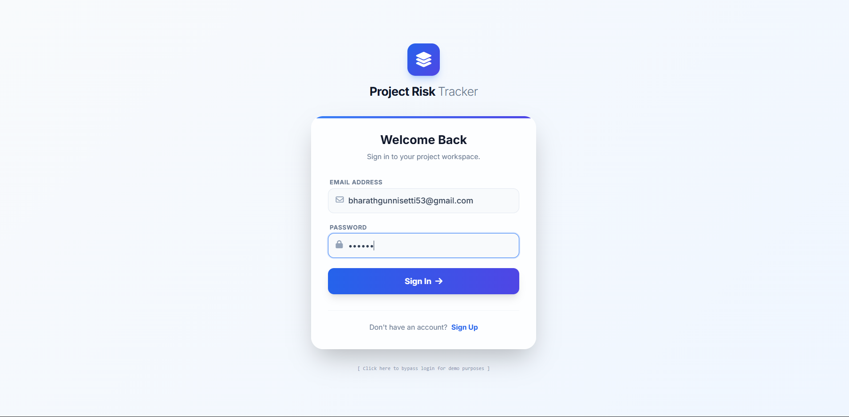
Figure 1.1 : login page
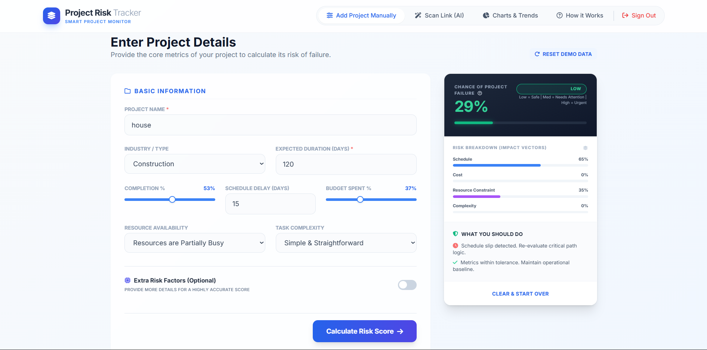
Figure 1.2 : project risk score
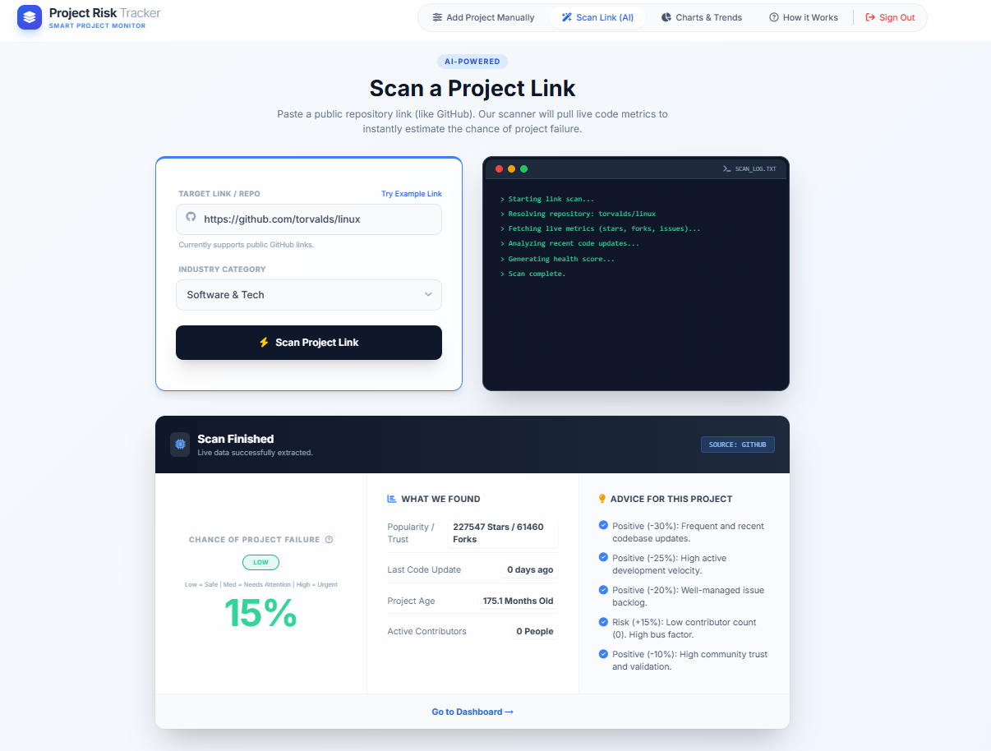

Figure 1.3 : project risk score through repo link
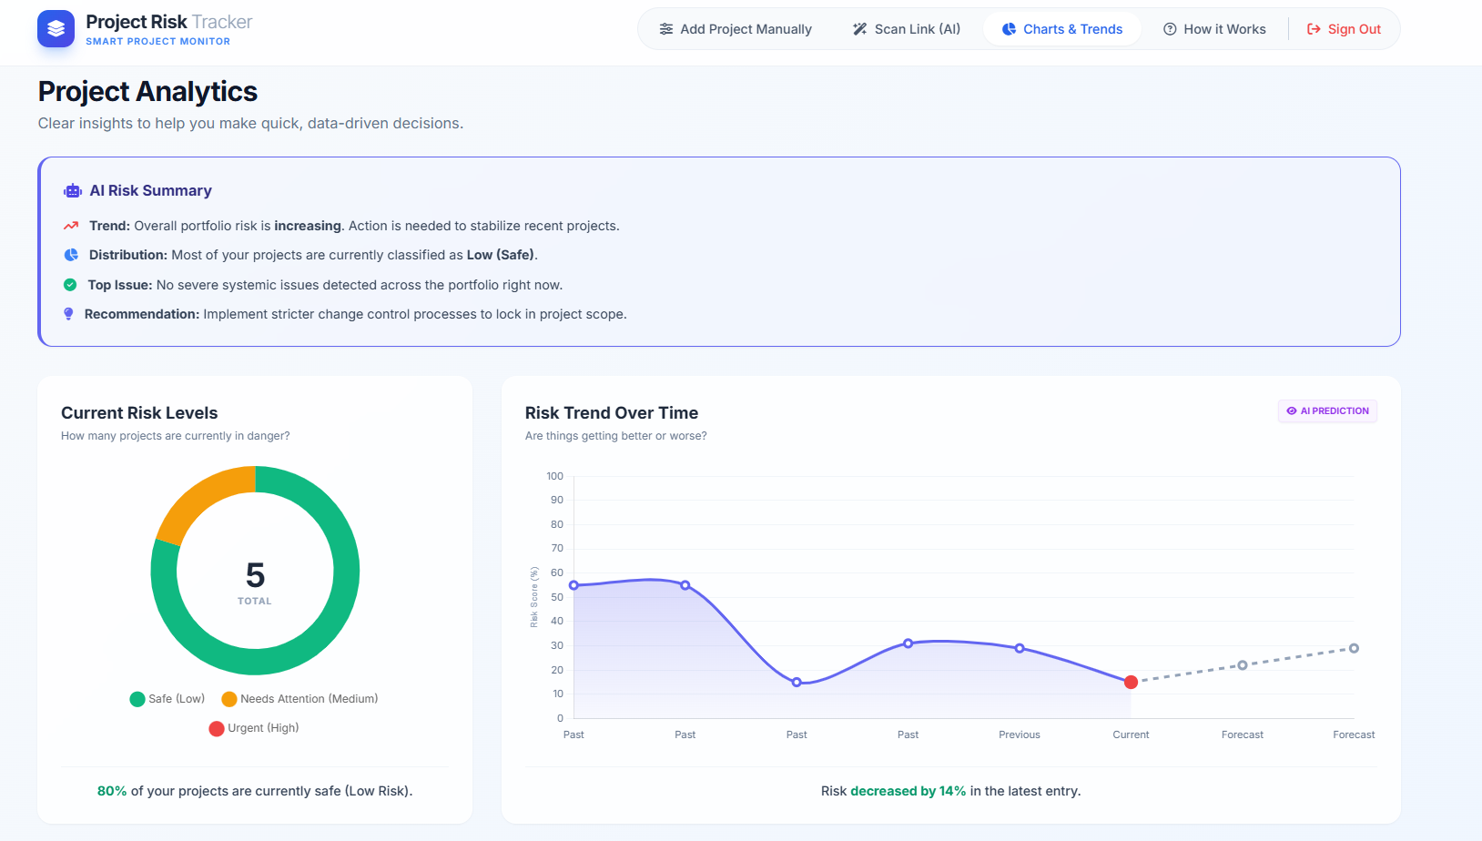
Figure 1.4 : project analytics

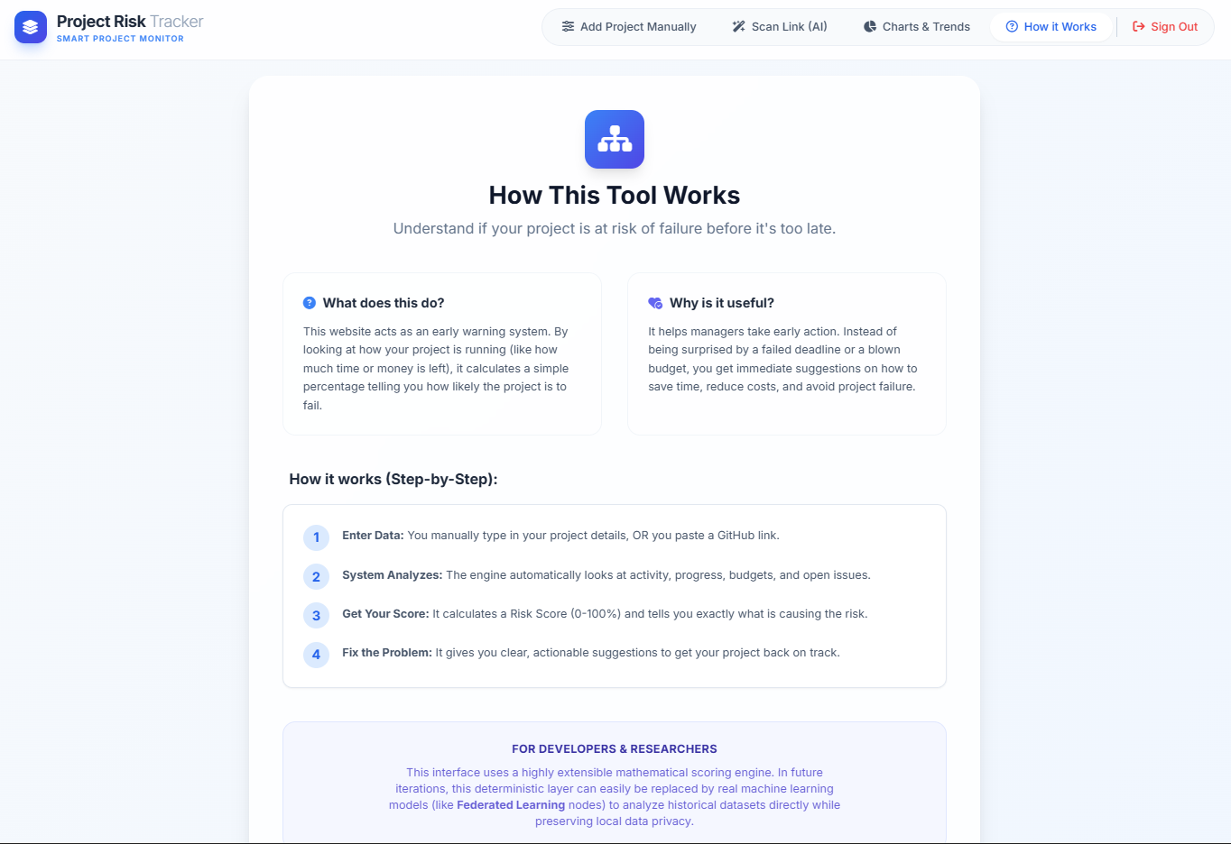
Figure 1.5 : about section
Table 1.1 Category
Stage | User Action | System Response | Output
1 | User Signup/Login | Authenticate using JWT | User Dashboard
2 | Enter Project Details / GitHub URL | Fetch and analyze data | Project Data Loaded
3 | Risk Analysis | Apply scoring/ML model | Risk Score
4 | View Dashboard | Display charts & insights | Risk Visualization
5 | Save Project | Store in MongoDB | Saved Project Data
6 | View Recommendations | Generate AI insights | Action Suggestions

